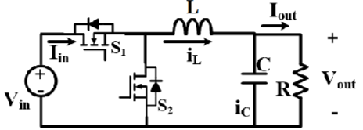  Buck Converter.  RMS Current Stress on S1/S2/L. Output V ripple magnitude.  $I_{RMS,L}=√{{(I}_{out}}^{2}+\frac{1​}{12}Δ{I_{L}}^{2})$ $I_{RMS,S1}=I_{RMS,,L}*√D$ , $I_{RMS,S2}=I_{RMS,,L}*√1-D$ , $ΔV_{out}=\frac{ΔI_{L}​}{8fC}$  $P_{cond,S2}={I_{L,rms}}^{2} * R_{ds(on)}(1-D)$  Effect of raising and lowering f while holding Vin, Vout, Iout, and L constant are • Slopes of iL are unchanged, • Lowering f increases ΔI and moves the circuit toward discontinuous operation time.  Effect of raising and lowering L while holding Vin, Vout, Iout and f constant are • Lowering L increases ΔI and moves the circuit toward discontinuous operation time.  RMS of common periodic waveforms  $I_{pp}=I_{max}-I_{min} , {I^{2}}_{rms}=\frac{{I_{pp}}^{2}​}{3}+I_{min}I_{pp}+{I_{min}}^{2}$  $I_{min}=I_{avg}-\frac{{I_{pp}}^{}​}{2} , {I^{2}}_{rms}=\frac{{I_{pp}}^{2}​}{12}+{I_{avg}}^{2} ,$$I_{RMS,L}=\frac{4​}{3}*{I_{out}}^{2}$  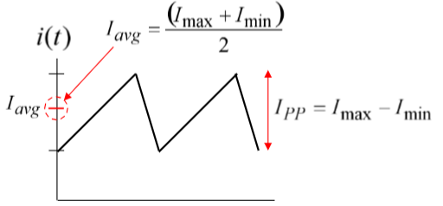  Peak/valley of the inductor current. Closed S (Vin-Vout)/L. Open -Vout/L.  $ΔI_{L}​=\frac{V_{out}​(1−D)​}{fL}$ , $I_{out}​=\frac{P_{out}​}{V_{out}}$ , $I_{peak}​=I_{out }+\frac{ΔI_{L}​}{2}$ , $I_{valley}​=I_{out }-\frac{ΔI_{L}​}{2}$ | 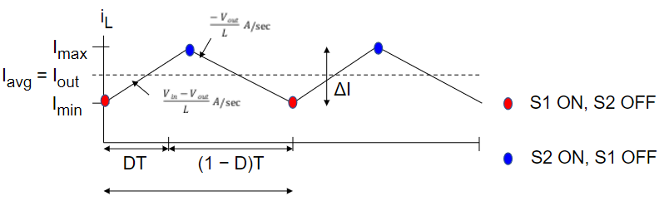  Inductor current rating: Boundary mode of conduction. margin of CCM and DCM  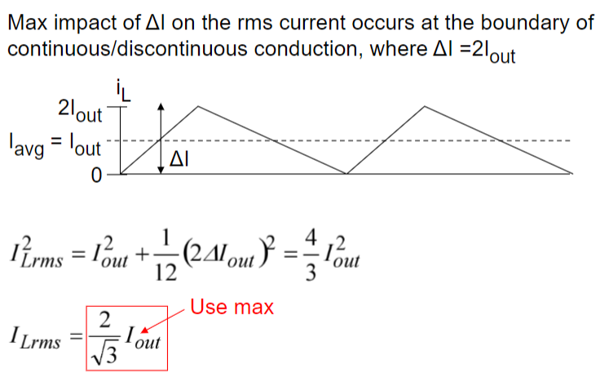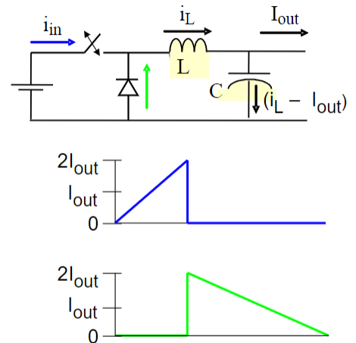  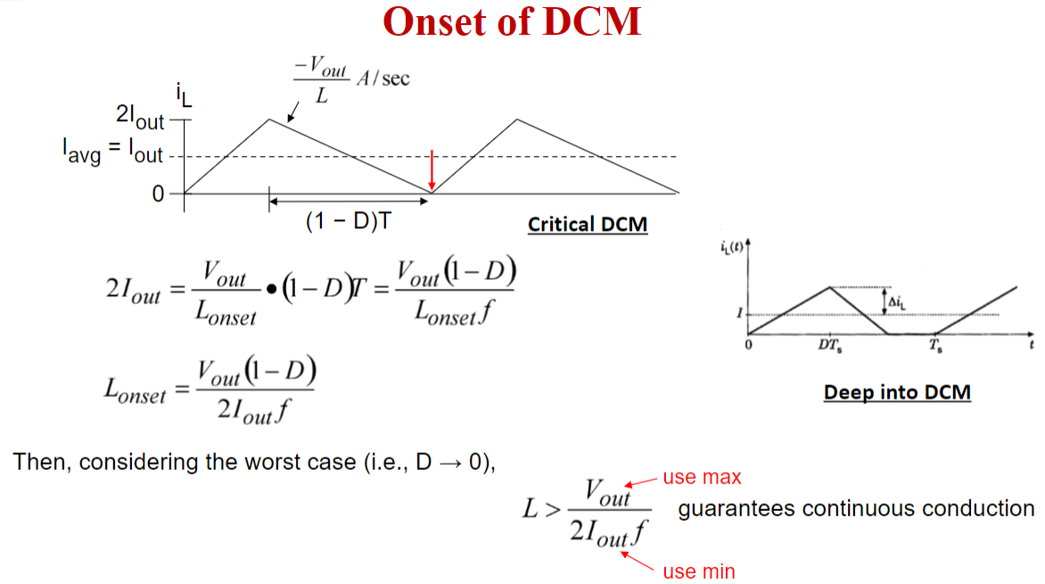

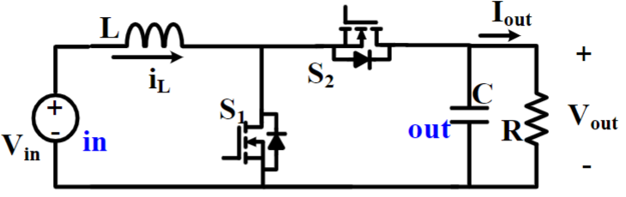  B) RMS Current Stress on S1/S2/L. Output V ripple magnitude.  $I_{RMS,L}=√{{(I}_{Lavg}}^{2}+\frac{1​}{12}Δ{I_{L}}^{2})$$I_{RMS,S2}=√{I_{RMS,L}}^{2}-{I_{RMS,s1}}^{2}$  $i_{s2}​ (t)=0;0<t<DT$ , $x−y⋅t,DT<t<T$  $x=I_{max}​ ;y=∣falling slope∣=\frac{V_{o}​-V_{in}}{L} ​$  $a=I_{min }, b=\frac{V_{in}}{L} , I_{RMS,s1}=√(a^{2}D +ab D^{2}T+\frac{b^{2}D^{3}T^{2}}{3}) ​$ | Boost Converter. A)Peak/valley of the inductor current  $ΔI_{L}​=\frac{V_{in}​​D}{Lf}$ ,$D​=1-\frac{V_{in}​}{V_{out}}$ ,$I_{out}​=\frac{P_{out}​}{V_{out}}$ , ${I_{in}=I}_{Lavg}​=\frac{I_{out}​}{1-D}$$I_{peak}​=I_{out }+\frac{ΔI_{L}​}{2}$ , $I_{valley}​=I_{out }-\frac{ΔI_{L}​}{2}$  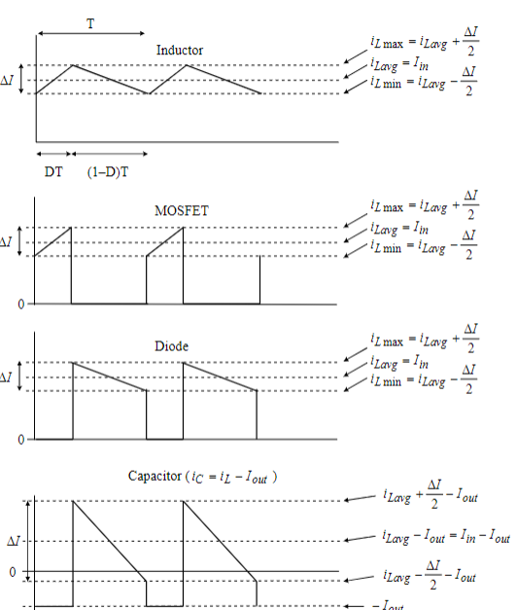

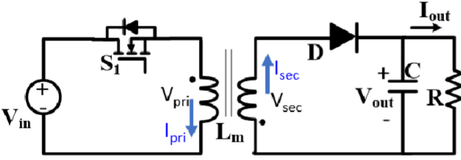FlybackDCDC  $P_{Clamp}=\frac{{V_{C}}^{2}}{R_{clamp}},R_{Clamp}=\frac{{{2V}_{C}(V_{C}-nV_{out})}^{}}{L_{lk}{I_{p}}^{2}f_{sw}}$, $C_{Clamp}=\frac{{V_{C}}^{}}{V_{ripple}R_{Clamp}f_{sw}} ,P_{leakage}=\frac{{1L_{lk}{I_{p}}^{2}}^{}}{2}$  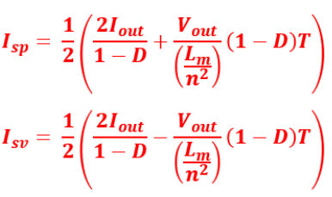 | $T​=\frac{1}{f_{sw}}$ ,$\frac{V_{out}​}{V_{in}}​=\frac{N_{2}​}{N_{1}}*\frac{D​}{1-D}$ ,$I_{out}​=\frac{P_{out}​}{V_{out}}$ ,$V_{pri}​=\frac{-V_{out}N_{1}}{N_{2}}$, $t_{on}=D*T,t_{off}=(1-D)*T$. Vripple=5%, Ip=Isp  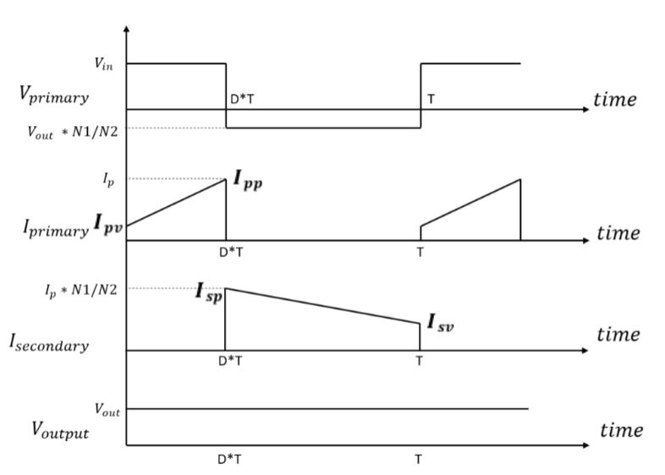  $Δt=\frac{L_{lk}{I_{p}}^{}}{V_{C}-nV_{out}} , N_{1}I_{pp}=N_{2}I_{sp}$

DON'T FORGET MEGA MILLI MICRO CONVERSION FACTORS

SRC, Series Resonant Converter. Gain cant be more than 1.  $R_{ac}=\frac{R_{L}8}{π^{2}}, i_{s,pk}=\frac{πI_{o}}{2}, R_{L}=\frac{V_{o}}{I_{o}}$, $G=\frac{NV_{out}}{V_{in}}$  SRC, Series Resonant Converter ISOLATED  $R_{ac}=\frac{{N^{2}R}_{L}8}{π^{2}}, i_{p,pk}=\frac{πI_{o}}{N}, R_{L}=\frac{V_{o}}{I_{o}}$ ... Gain SRC:  ${@w=w_{r }; G=1, w}_{r}=\frac{1}{√L_{r}C_{r}}$  $@w≠w_{r }; G<1,Q=\frac{√L_{r}{/C}_{r}}{R_{ac}}$ …. Gain Relationship:  $\frac{nV_{out}}{V_{in}}=\frac{R_{ac}}{R_{ac}+j(wL_{r}- \frac{1}{wC_{r}})},G=\frac{R_{ac}}{{√(R}_{ac}+j(wL_{r}- \frac{1}{wC_{r}})^{2})}$ | 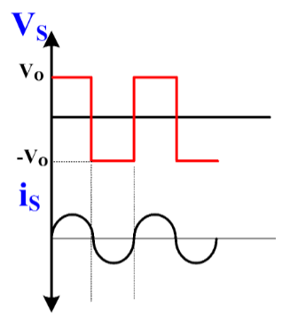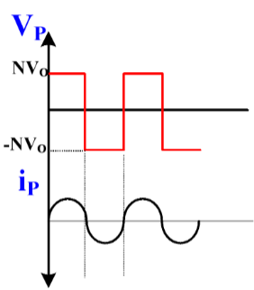  Input Impedance:  $Θ=tan^{-1}(\frac{(wL_{r}- \frac{1}{wC_{r}})}{R_{ac}})$  $P_{out}=\frac{{V_{o}}^{2}}{R_{L}}=P_{in}$

PRC, Parallel Resonant Converter. 1 is the sweet spot.  $R_{ac}=\frac{R_{L}π^{2}}{8}, v_{s,pk}=\frac{πV_{o}}{2}, R_{L}=\frac{V_{o}}{I_{o}}, G=\frac{R_{ac}}{w_{r}L_{r}}=Q^{-1}$  PRC, ISOLATED  $R_{ac}=\frac{{N^{2}R}_{L}π^{2}}{8}, i_{p,pk}=\frac{πI_{o}}{N}, N=\frac{V_{in}}{V_{o}}, G=\frac{NV_{out}}{V_{in}}$ ... Gain PRC:  ${@w=w_{r };G=\frac{R_{ac}}{w_{r}L_{r}}=Q^{-1}, w}_{r}=\frac{1}{√L_{r}C_{r}} , Q=\frac{√L_{r}{/C}_{r}}{R_{ac}}$  |$\frac{nV_{out}}{V_{in}}|=G=\frac{1}{√(\frac{w^{2}{L_{r}}^{2}}{{R^{2}}_{ac}}+(1-w^{2}L_{r}C_{r})^{2})}$ | 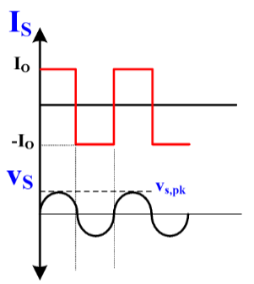 InputImpedance:  $Θ=tan^{-1}(\frac{1}{R_{ac}wC_{r}})$  $I_{p,rms}=\frac{4V_{in}}{π√2}$
\

LLC Resonant Converter: Series Inductance (Lr​): Determines resonance and energy transfer.  Resonant Capacitance (Cr): Defines the resonant frequency along with Magnetizing Inductance (Lm​): Impacts the converter’s gain and phase. Load Resistance (Rac): Reflected resistance on the primary side. Transformer Turns Ratio (n): Voltage step-up or step-down ratio.  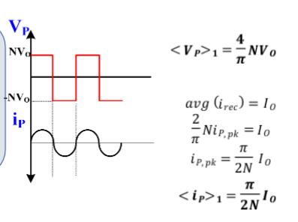  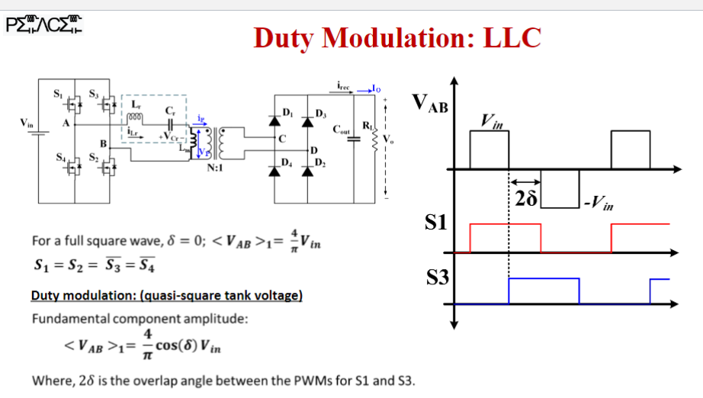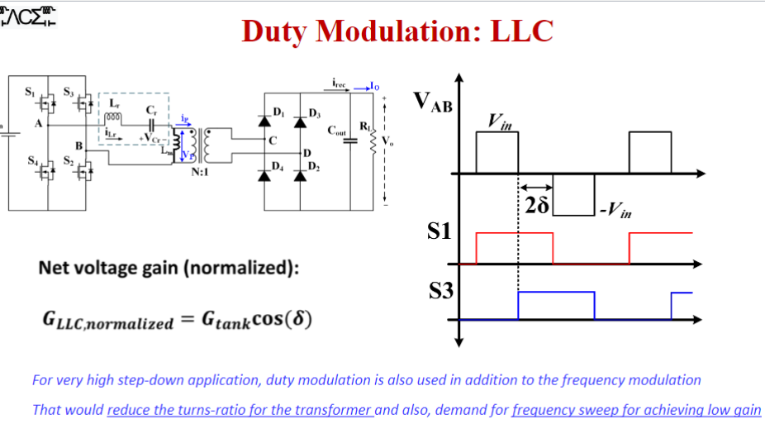 | 